Strayer University

ACCESS CONTROL SYSTEM

Week 4

Case Study Assignment

for the

Course of

Systems Analysis and Development

05/01/17

By

Kennedy Kabaso.

Professor: Irene Hoskins.

ACCESS CONTROL SYSTEM

**About the Access control System**

Access control is a security technique that can be used to regulate who or what can view or use resources in a computing environment. Access control systems is the way of performing an authorization identification, authentication, and accountability of entities using a Pin number or other login methods. Access control can be of physical, which controls access to the compass buildings, rooms and Computers and can be of Logical, which controls access to computer networks, system files and data. On this project, a lots of security features will be added to conduct access on the compass into the student’s dormitory. Students will be given access into their dormitory using an access control system (ACS). This will be achieved using an electronic proximity reader where they can scan their card or badger, which will unlock the dormitory doors automatically. In addition, the will be cameras which are designed to face and rotate to record a person as they use their identification card to unlock the door**.** The card reader sends the data of the person to an intelligent door controller which contains stored programming information from the access control software about who is allowed in the dormitory and at what time. The project will give the College the ability to control, manage and monitor the access of each students and staff inside the dormitories.

**Project Scope Statement**

The project scope is the installation of the Access Control System which is going to control the entrance of an individual into the Students Dormitory. Therefore, a person who wants to get into the student dormitory will have to scan his or her card on a reader which will check that information in a database and grant access which will result in opening of the door of the dorms. Moreover, the will be a Security camera which will work in conjunction with the reader to make this thing work properly.

**TASKS**

In this assignment, I’m going to explain five task which are needed to do this whole process. Then broken those task into subtask to make it easy to understand. Therefore, the first task will be to employed people to do the job, the second one will be to take a tour of the campus, the third one will be to buy the equipment needed for the job, the four one will be to install the equipment, and bring the specialist to test the equipment and the last one will be to handover this to the security company to handle the job.

**Task 1**

The first task is to look for workers to do the job

* Construction worker to install the readers.
* The Access Control System team to do the installation.
* Find two good companies who are good at install the whole system.
* Compare price and come up with an affordable one.
* Select one company out of two to do the job.

**Task 2**

Tour the campus and buy the equipment needed for the job

* Come out with the team to go around the campus.
* See all the places which needed the install of the Raeder and cameras.
* Look the equipment’s which are quality and affordable.

**Task 3**

Install the equipment’s.

* Install the whole system by the company which is going to be chosen from the two.
* Install the Cameras all around the Dorms Entrances
* Install the Control panel.
* Install the Reader.

**Task 4**

Bring the specialist to test the equipment.

* A company to test the equipment make sure it is working properly.
* Train the security personal how to use the system.

**Task 5**

Handover ACS to the security company to handle the job.

* Find a local security company to take over the job of securing the dorm.
* Make the cards to work with the system for the students and staff’s members.
* Put a maintenance company to be doing the maintained.

I have put the whole process in a form of a diagram using a flow Cart below. In the flow cart, A person can scan a card on any of the places where there are reader and a camera which send the information to the control panel which send them and check in the database. If the data is there, it sends a reply which grant access to the card and open the door but if it is not there, then it does not open the door. Then the person who scan the card knows that he or she is not allowed to enter the dorm.

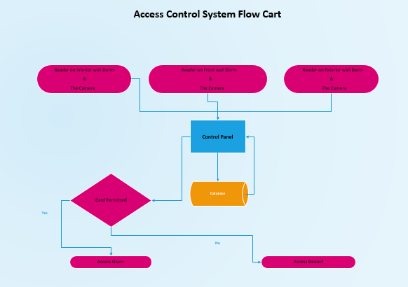

I have put everything about the task in a Gantt cart below. The Gantt cart shows how long the tasks are going to take. The duration of tasks are in weeks as you can see from the cart.

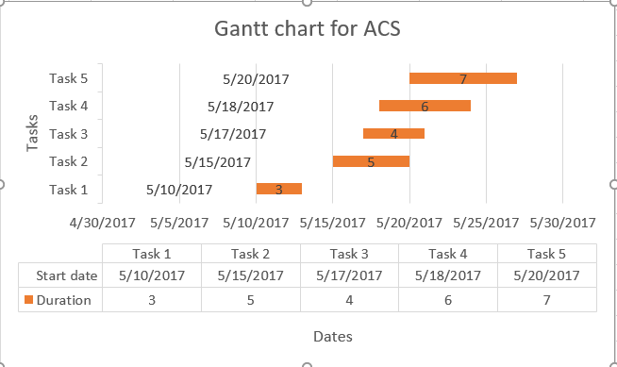

**Bibliography**

1. <http://www.securitymagazine.com/articles/84074-how-to-build-a-complete-access-control-system>
2. <https://www.google.com/#q=what+is+an+Access+Control+Systems>
3. <http://www.maglocks.com/cobra-controls-acp-1n-1-door-computerized-access-control-system-kit-by-cobra-controls-for-1559.html>
4. <https://en.wikipedia.org/wiki/Access_control>